**Requirement –**

Create Report which will take input ‘Plant’ from default screen and on executing will display all the materials extended on this plant. When click on any material, new list will be displayed which will show that the same material is extended to which plants.

**Input Screen –**

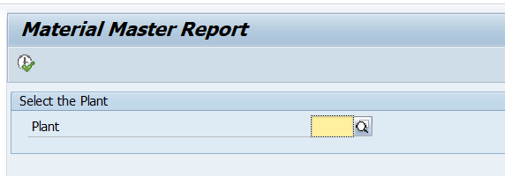

**Validations on Input Screen –**

1. If plant is not entered and report executed, display error message.

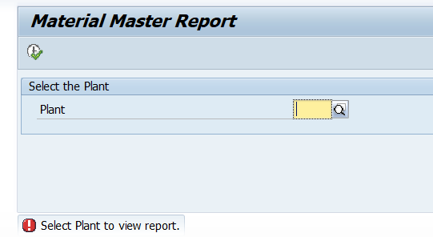

1. If plant entered is not extended to any material display error message.

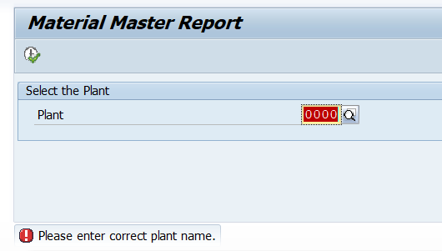

**Output (Material extended to Plant)**

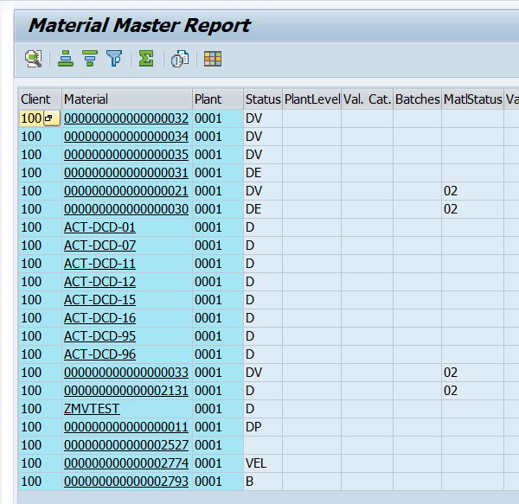

**Output (All plants to which selected material extended)**

